Use this reference to create announcements on the Workday Landing Page.

Table of Contents:
(Ctrl+click to jump to content)

Create Announcement 1
Announcement Settings At a Glance 2
Announcement Settings in Detail 3
Preview Announcement 6

INSTRUCTIONS

Create Announcement

- In the search bar, type “Configure announcements” and select the Configure Announcements task.

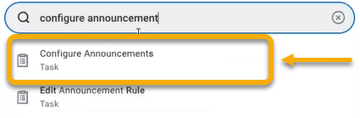

- In the Configure Announcements window, locate the Dashboard field and enter “Home”. If it does not appear in the search, click the field and select “All”. Scroll down and select “Home”.

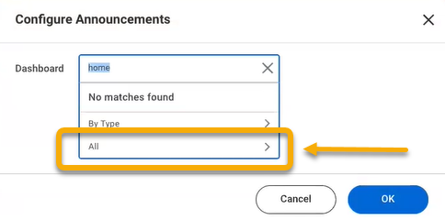

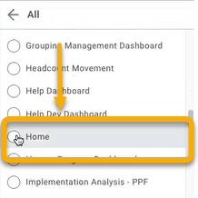

- Click “OK”.

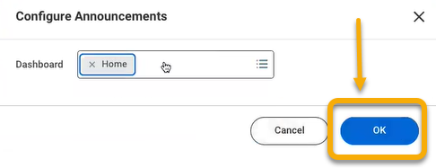

Announcement Settings At a Glance

This is the announcement configuration table at a glance. For details, proceed to the steps outlined in this guide.
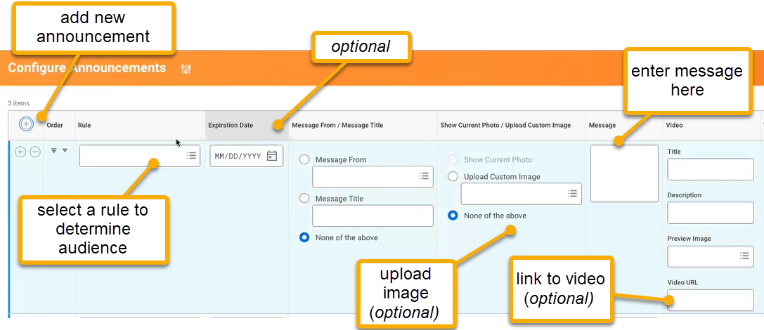
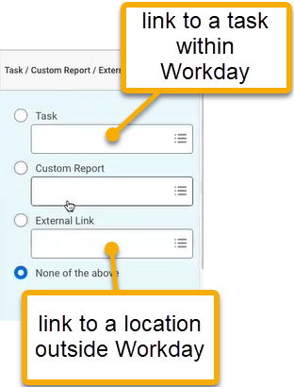

Announcement Settings in Detail

- The Configure Announcements configuration table will appear. To create a new announcement, click the plus sign in the top left corner of the table.


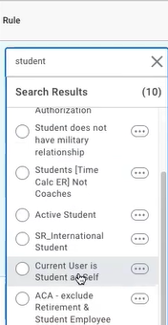
- To select the audience for the announcement, click the Rule column to view options. In this example, “student” is entered into the search field to narrow the selections.

- In the Expiration Date field, you may select an expiration date for the announcement. This is optional.

- In the Message From / Message Title column, complete as needed. This is optional. If neither is desired, select “None of the above”.

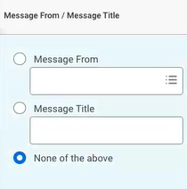

- In the Show Current Photo / Upload Custom Image column, you may upload an image from your computer to contain or accompany the announcement. If no image is desired, select “None of the above”.

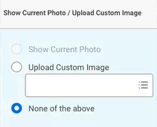

- In the Message column, you may enter text. You may also format the text as desired, including adding hyperlinks, bullet points, ect. Click “Done” when finished.

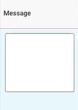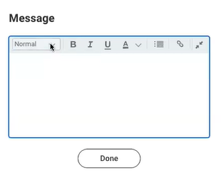
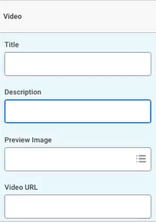
- In the Video column, you can upload a video. You have the option to include a custom preview image, title, and description.

If uploading a video, including a preview image is strongly recommended.

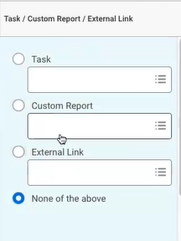
- In the Task / Custom Report / External Link column, you can automatically link the audience to a task, such as onboarding, or report within Workday or to an outside link, such as a Google form.

Preview Announcement

Once configured, it is important to preview the announcement. To do this in Workday, you must proxy as an individual who should be included in the rule selected for the announcement.

As the proxy, test all hyperlinks, videos or images to ensure the announcement is working properly.

